**DAILY ONLINE ACTIVITIES SUMMARY**

|  |  |  |  |  |  |  |  |  |
| --- | --- | --- | --- | --- | --- | --- | --- | --- |
| **Date:** | **26/05/2020** | | | | | **Name:** | **V ANJANA PAI** | |
| **Sem & Sec** | **IV sem & B section** | | | | | **USN:** | **4AL18CS094** | |
| **Online Test Summary** | | | | | | | | |
| **Subject** | | **DESIGN AND ANALYSIS OF ALGORITHMS** | | | | | | |
| **Max. Marks** | | **30** | | **Score** | | | **25** | |
| **Certification Course Summary** | | | | | | | | |
| **Course** | **Python for Machine Learning** | | | | | | | |
| **Certificate Provider** | | | **Greatlearning academy** | | **Duration** | | | **5.0 hours** |
| **Coding Challenges** | | | | | | | | |
| **Problem Statement1:** Given an array A of size N where the array elements contain values from 1 to N with duplicates, the task to find total number of subarrays which start and end with the same element.  **Problem Statement2:** Write a program in C to print all permutations of a given string using pointers. | | | | | | | | |
| **Status: Executed** | | | | | | | | |
| **Uploaded the report in Github** | | | | | **YES** | | | |
| **If yes Repository name** | | | | | **lockdown-coding** | | | |
| **Uploaded the report in slack** | | | | | **YES** | | | |

Online Test Summary: 18CS42 test was scheduled from 9:15 am t0 10:00am. The portion for the IA was 2nd module there were 30 questions and the time assigned was 45 minutes the questions was mcq type and some problems were given to solve.

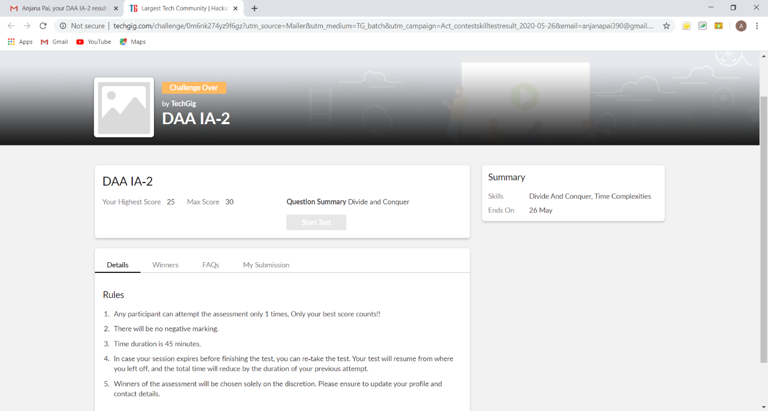

The above snap shot is the completion of the test and the marks allotted.

Online Certification Course Summary: Today I learnt about Saving and loading NumPy Arrays and also learnt about the introduction on Pandas which is a high-level manipulation tool developed by McKinney. And also learnt about Pandas- Series and Data frames, Accessing and Modifying.

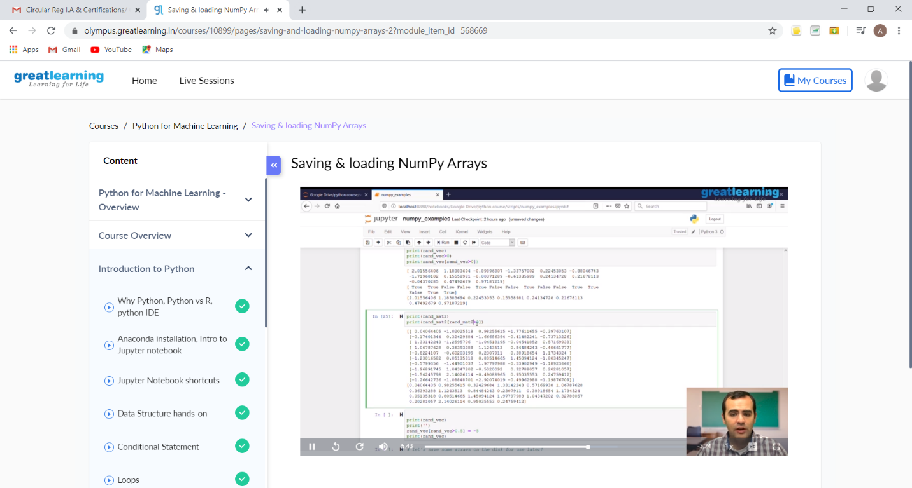

This is the snap shot of the last session that is where I learnt about Saving and Loading NumPy Arrays.

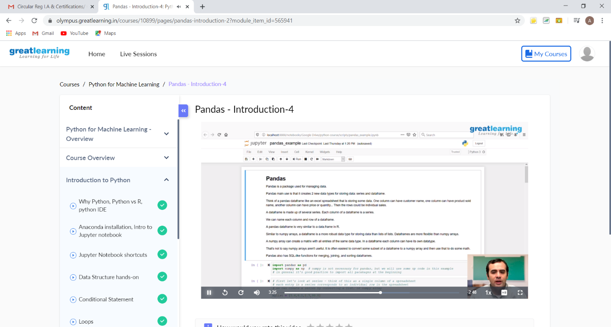

This is the snapshot of the session on, Introduction on Pandas.

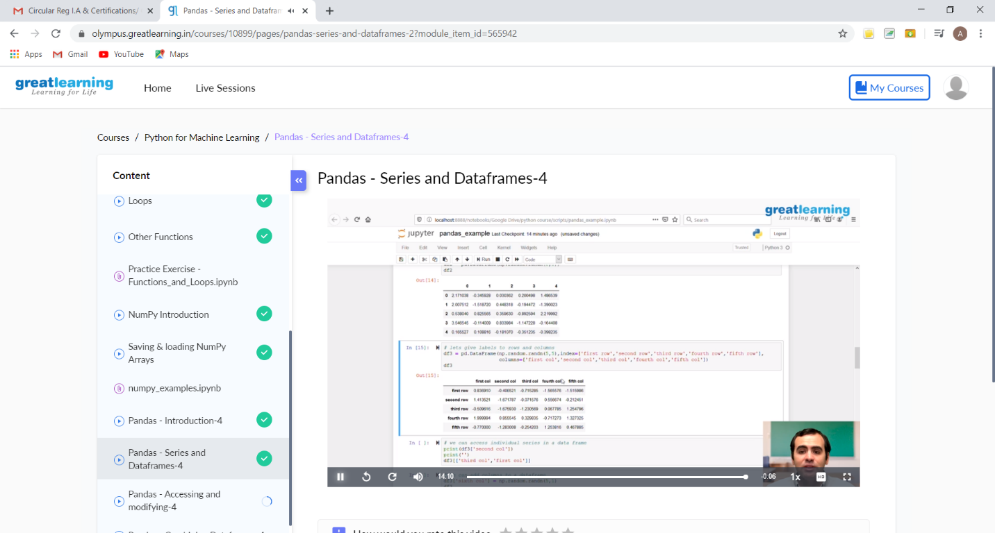

This the snapshot of the session on Series and Data frames.

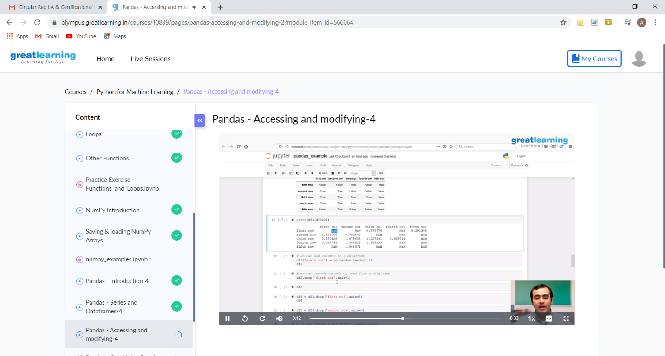

This is the snapshot of the session on Accessing and Modifying.

Online Coding Summary: **Today I had received one program from prof. Vasudev CSE Dept and another from prof. Venkatesh CSE Dept. The programs are mentioned above in the coding challenges(pg.01). I have also uploaded it to my Github repository.**

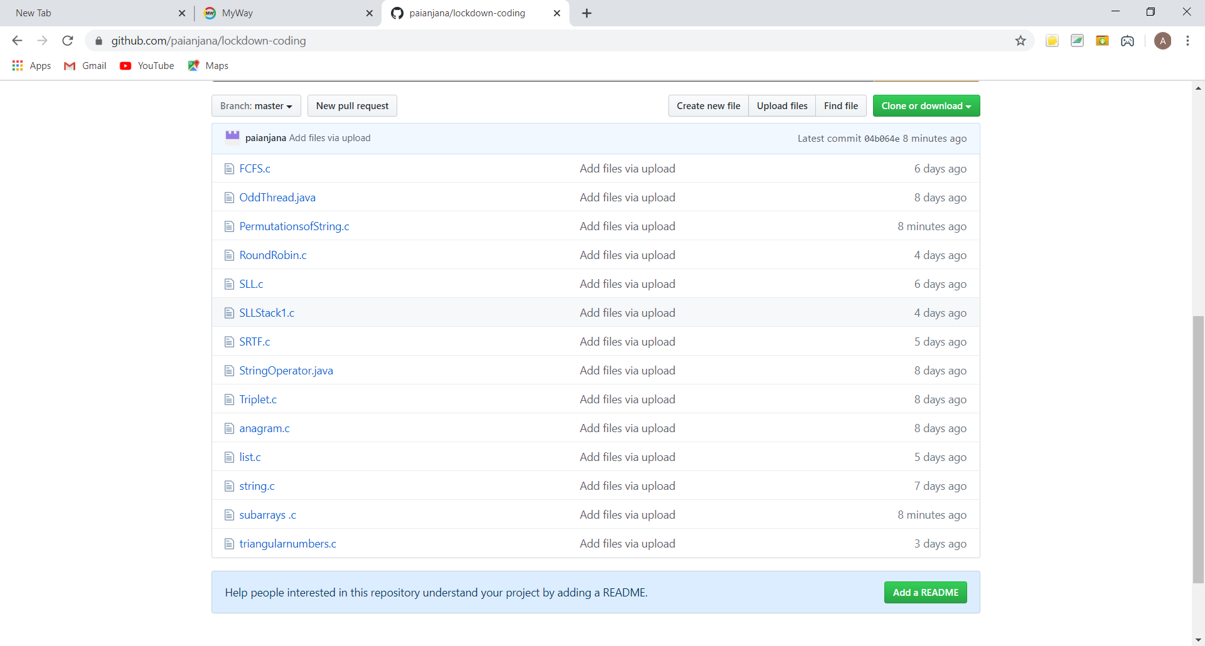

It is the snap shot of my repository where I have uploaded the code. File name is PermutationofString.c and subarrays.c